**Lab Assignment 2**

**Team : 5**

Kiran Rao Boinapally – class ID : 3

Sai Srinivas Vidiyala – class ID : 29

**Video Link :**

**Introduction** :

We are developing a Tic-Tac-Toe game using angular JS and creating a youtube search application using angular JS and youtube API.

**Objective** :

**Developing Tic-Tac-Toe game**

In this, we are implementing a 3*3 empty board where two players can participate in the game. The user wins if he has same sign either ‘X’ or ‘O’ diagonally, horizontally, vertically in three boxes.

**Youtube Application**

In this we are getting the videos from the youtube using the youtube api based on the input search keywords.

It displays all the videos related to the input keyword.

**Task -1 :**

Initially, we have imported all the required libraries.

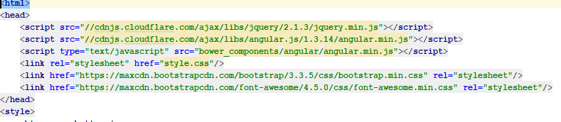

The code in this screenshot shows the 3*3 empty board UI.

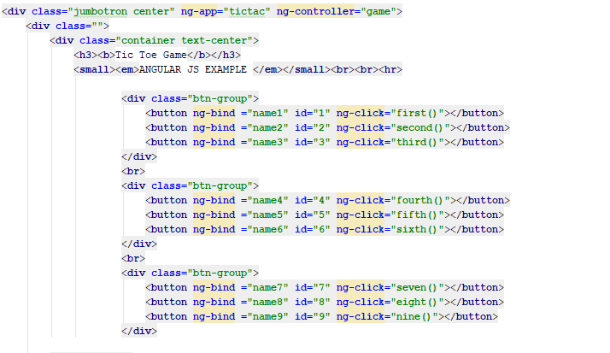

This part shows the number of clicks on the board and the final result using binding concept.

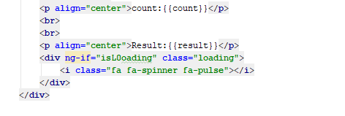

when the user presses any box, for example the first box, first method will be called.

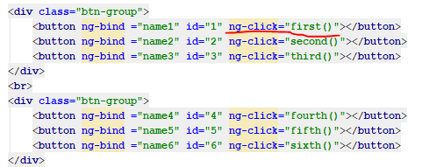

Following picture shows the logic for the first method.

On each click on tic-tac-toe board, count will be incremented and it checks for the even odd condition. If it is even ‘X’ will be displayed on the board and if it is odd, ‘o’ will be displayed. On the first click, as the count is 1, ‘O’ will be displayed on the board and ‘O’ count will be incremented by 1.

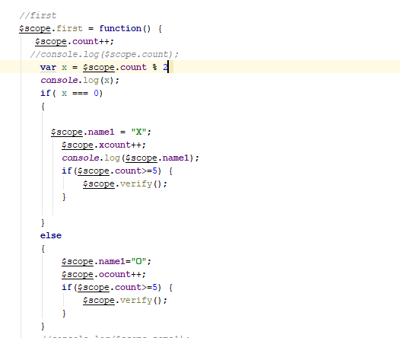

When the user clicks on the second button, the secong method will be called and total count will be incremented by 1. So, in this case as the count is even, ‘X’ will be displayed on the button and the xcount also will be incremented by 1.

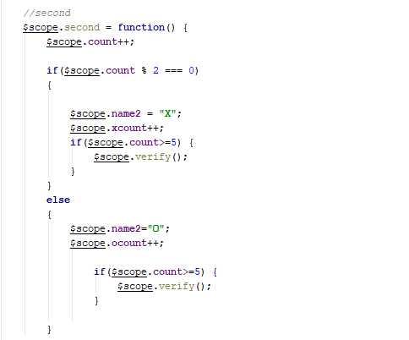

When the count is greater than or equal to 5, verify function will be called and it checks for any winning condition. In the present scenario, on click of 9th button, a diagonal line of ‘O’ is formed and hence it shows “O won” in alert message.

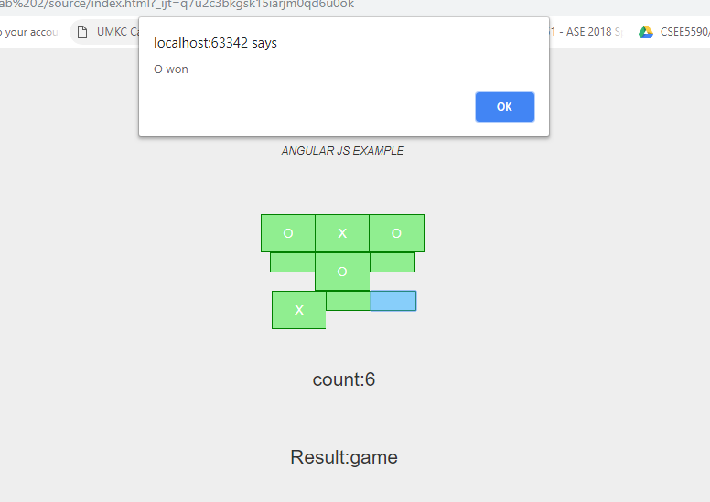

When we clicked on “ok” in the alert box, shows as “O” won as shown in the below figure.

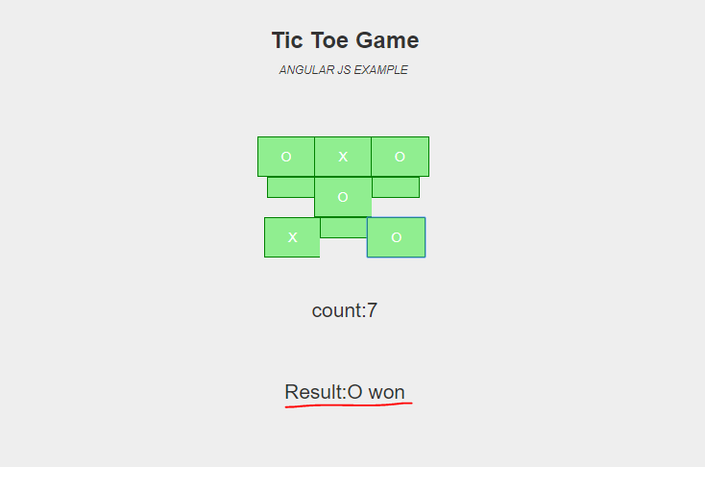

Below screenshot shows the logic for the verification. In this case, as we have “O” in 1, 5, 9, boxes , so it prints the text in the alert box as “O” won.

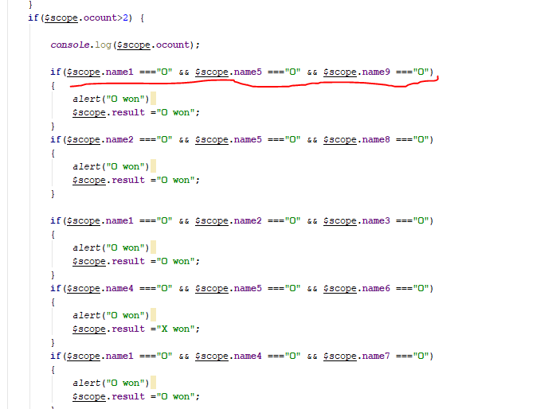

Similarly, for all the remaining cases it follows like this. Following picture shows the “o” win on the last click.

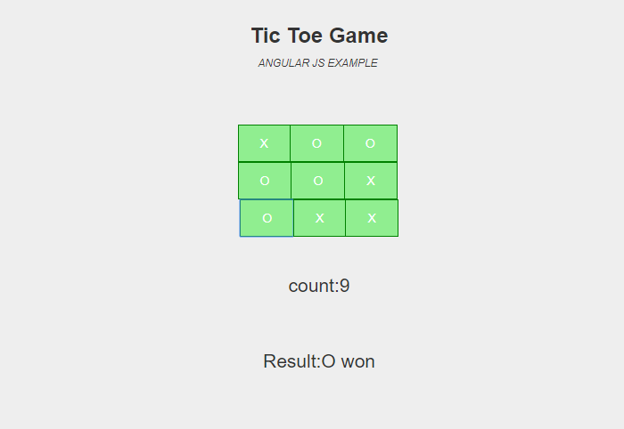

**Task: 2**

Following picture shows the code for the navigation bar in the UI.

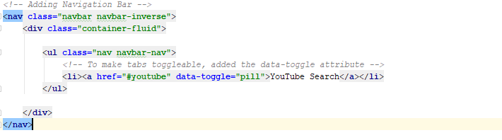

This screenshot shows the code for the body part of the UI. Here we initialized a heading and an input box and a button for searching. We used ng-click function, upon clicking the search button getYouTubeDetails() function will be called.

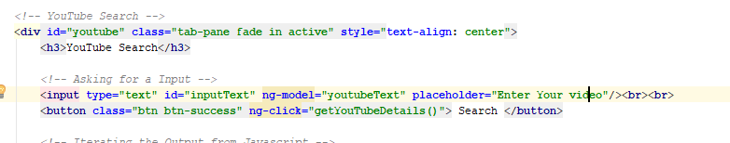

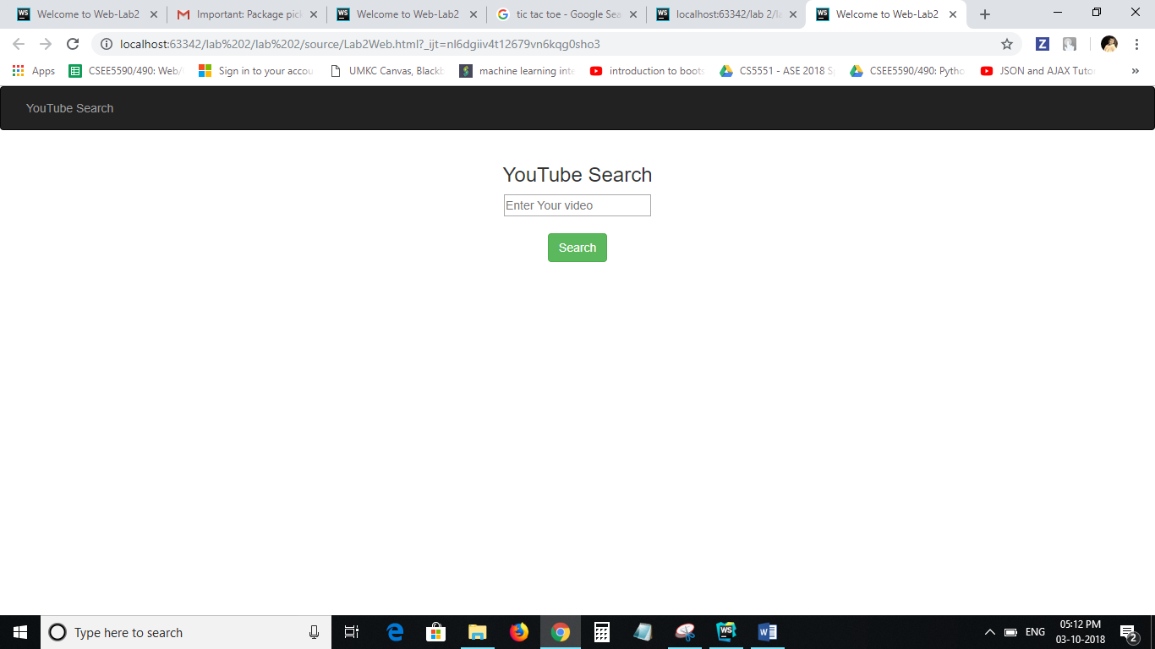

Initially an empty array youTubeVideos is created. Using the youtube api and the generated key from the you tube developer options, we extracted the data from the youtube by searching the keyword in the input box.



Here all the data extracted from the api is stored in the youTubeVideos array.

The following code displays the all the videos through the iteration using ng-repeat directive.

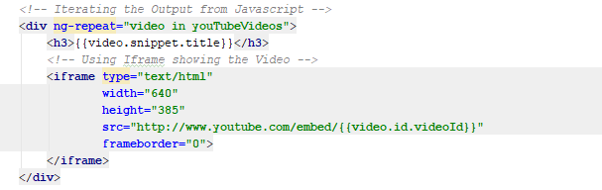

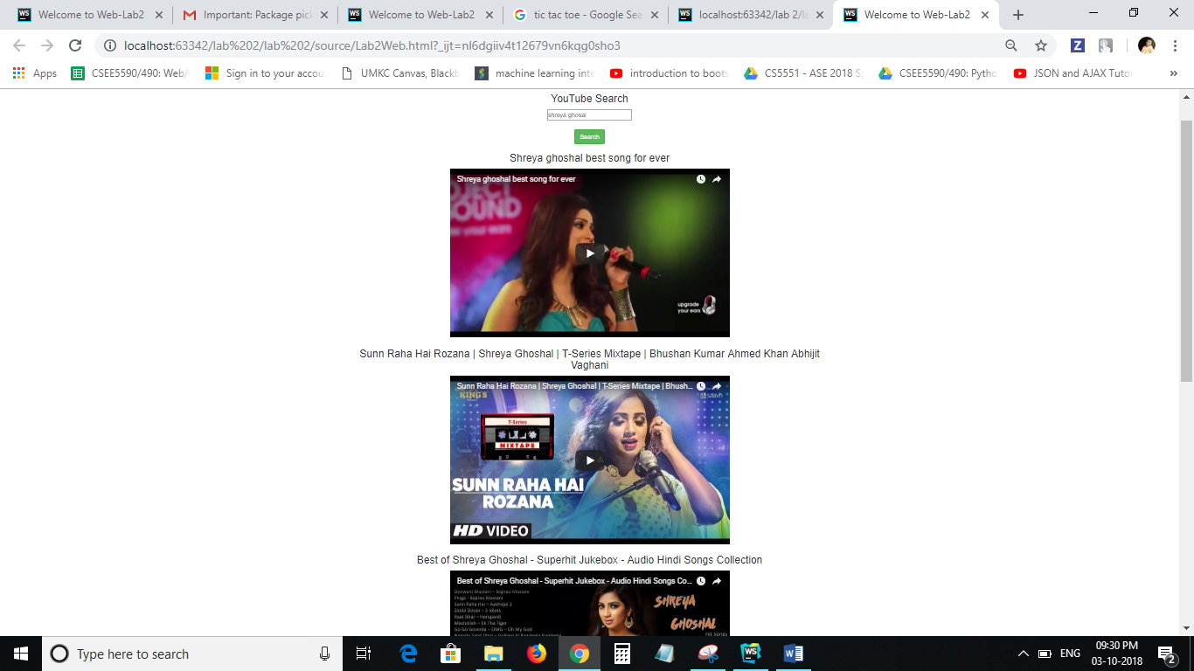

If there is no related data for the input searched keyword, it shows that “no youtube records exist for the input text”. For that we have written the following condition.

$scope.**youTubeVideos**.**length** < 1

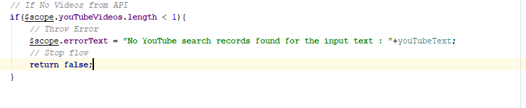

If the user clicks the search button without entering the input text it shows that the ”Input Text should not be empty”. We have written the following code for this execution.

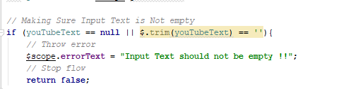

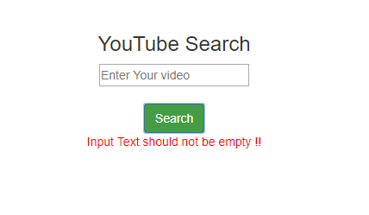

**References:**

<https://www.w3schools.com/>

<https://stackoverflow.com/>

<https://www.youtube.com/>